**CS:4400 Data Attribute Collection**

**Team #5**

**Login**

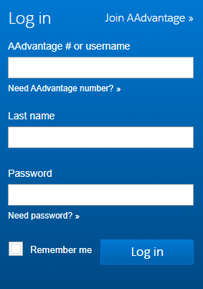

|  |  |  |  |
| --- | --- | --- | --- |
| **Data Attribute** | **Type of Entry** | **Data Type** | **Comments** |
| AAvantage/ Username | Entry | Alphanumeric | Required, PK, UN |
| Last Name | Entry | Alpha | Required, NN |
| Password | Entry | Alphanumeric | Required, NN |

**Book**

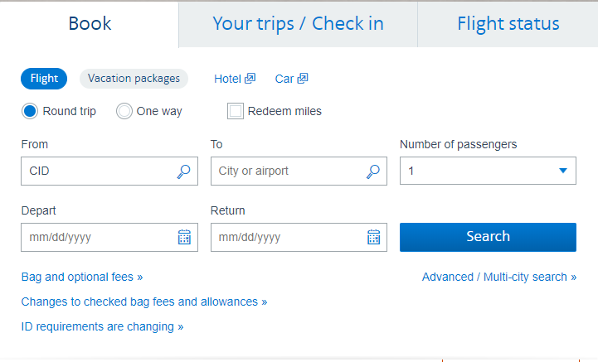

|  |  |  |  |
| --- | --- | --- | --- |
| **Data Attribute** | **Type of Entry** | **Data Type** | **Comments** |
| Round trip/One way | Select | Integer | Required, NN |
| Redeem miles | Checkbox | Boolean | Optional |
| From | Entry/Drop Down | Alpha | Required, NN |
| To | Entry/Drop Down | Alpha | Required, NN |
| Depart | Entry/Pick | Date | Required, NN |
| Return | Entry/Pick | Date | Required, Optional in One Way, NN |
| # of Passengers | Drop Down | Integer | Required, 1-9, NN |

**Your trips**

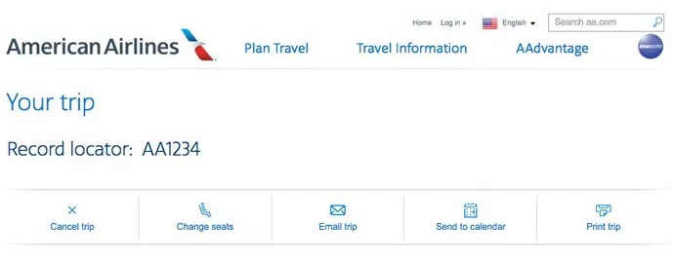

|  |  |  |  |
| --- | --- | --- | --- |
| **Data Attribute** | **Type of Entry** | **Data Type** | **Comments** |
| First Name | Entry | Alpha | Required, NN |
| Last Name | Entry | Alpha | Required, NN |
| Record locator | Entry | Alpha | Required, 6 letter code, PK |

**Flight Status**

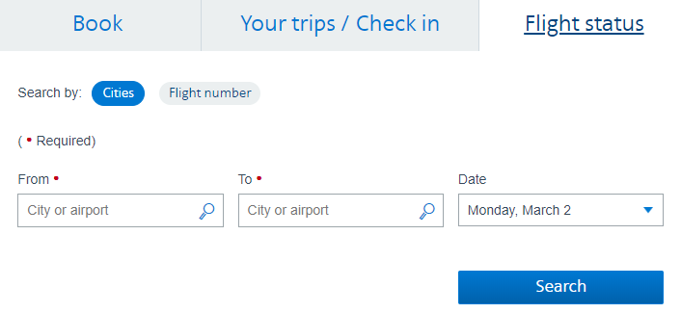

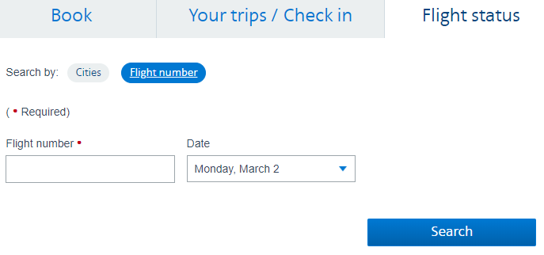

|  |  |  |  |
| --- | --- | --- | --- |
| **Data Attribute** | **Type of Entry** | **Data Type** | **Comments** |
| From | Entry/Drop Down | Alpha | Required, NN |
| To | Entry/Drop Down | Alpha | Required, NN |
| Date | Entry/Pick | Date | Required, Default today, NN |
| Flight Number | Entry | Alphanumeric | Required, FK |

**Advanced Search**

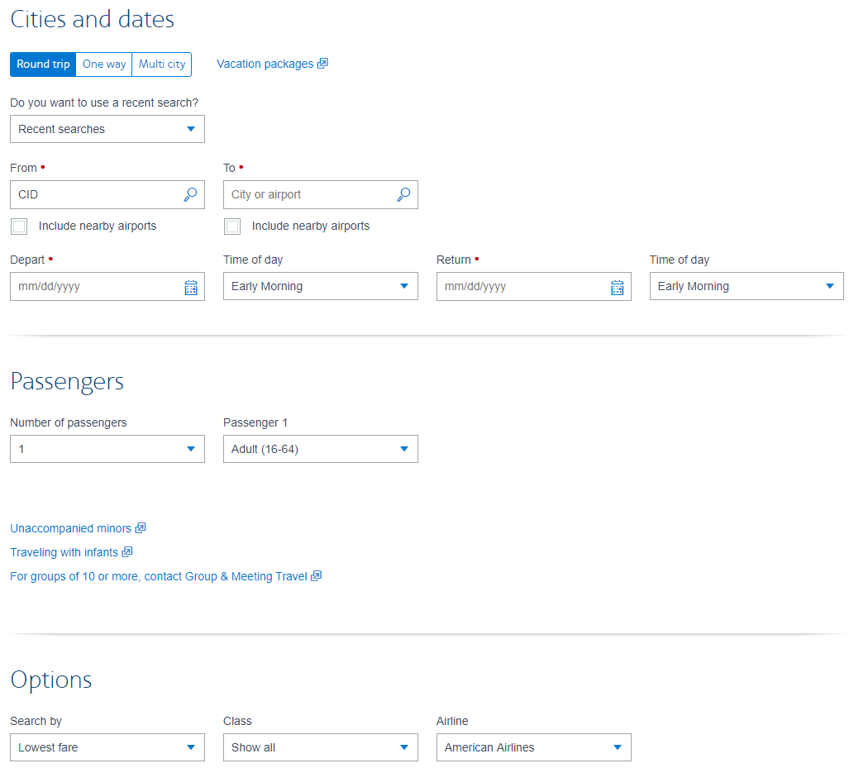

|  |  |  |  |
| --- | --- | --- | --- |
| **Data Attribute** | **Type of Entry** | **Data Type** | **Comments** |
| Redeem miles | Checkbox | Boolean | Optional |
| Round trip/One way/Multicity | Select | Integer | Required, NN |
| From | Entry/Drop Down | Alpha | Required, can have up to 6 for multicity, NN |
| To | Entry/Drop Down | Alpha | Required, can have up to 6 for multicity, NN |
| Depart | Entry/Pick | Date | Required, can have up to 6 for multicity, NN |
| Time of day | Drop Down | Alpha | Optional, can have up to 6 for multicity, NN |
| # of Passengers | Drop Down | Integer | Required, 1-9, NN |
| Age group | Drop Down | Integer | Required, Default Adult, NN |
| Search by | Drop Down | Alpha | Required, 2 choices |
| Class | Drop Down | Alpha | Required, Default Show all, NN |
| Airline | Drop Down | Alpha | Required, Default AA, NN |

**Admin Panel**

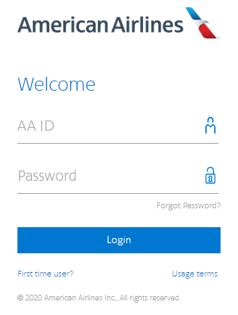

|  |  |  |  |
| --- | --- | --- | --- |
| **Data Attribute** | **Type of Entry** | **Data Type** | **Comments** |
| Username | Entry | Alphanumeric | Required, PK |
| Password | Entry | Alphanumeric | Required |

**Aircraft**

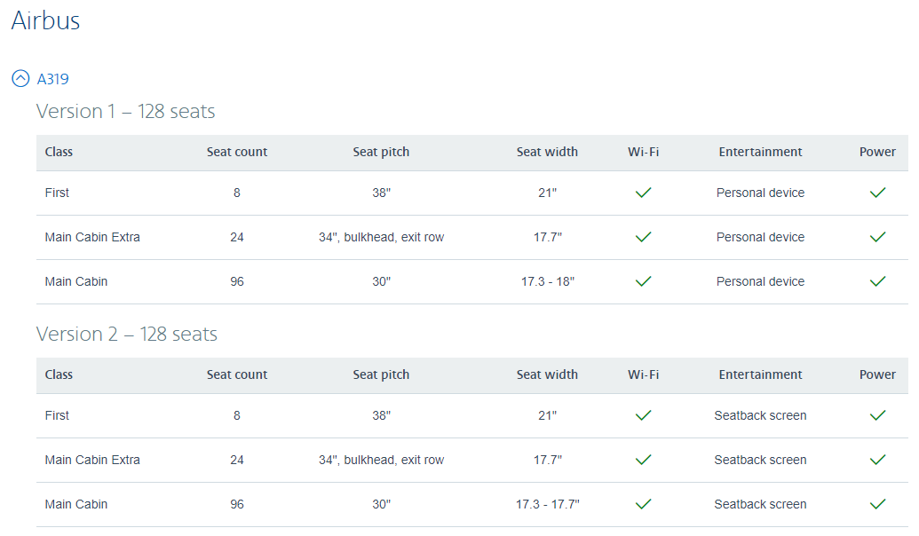

|  |  |  |  |
| --- | --- | --- | --- |
| **Data Attribute** | **Type of Entry** | **Data Type** | **Comments** |
| Aircraft ID | Entry | Alphanumeric | Required, PK |
| Aircraft Name | Entry | Alphanumeric | Required, NN |
| Seats | Entry | Integer | Required, Positive, NN |
| Seat pith | Entry | Alphanumeric | Required, NN |
| Seat width | Entry | Alphanumeric | Required, NN |
| WIFI | Select | Boolean | Required, NN |
| Entertainment | Entry | Alpha | Required, NN |
| Power | Select | Boolean | Required, NN |

**Enroll**

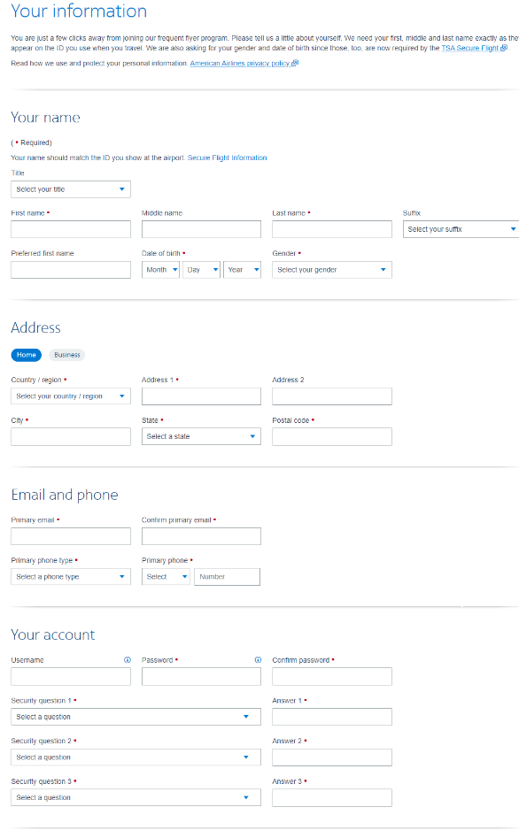

|  |  |  |  |
| --- | --- | --- | --- |
| **Data Attribute** | **Type of Entry** | **Data Type** | **Comments** |
| Title | Drop Down | Alpha | Optional, (MR., DR., etc.) |
| First Name | Entry | Alpha | Required, NN |
| Middle Name | Entry | Alpha | Optional |
| Last Name | Entry | Alpha | Required, NN |
| Suffix | Drop Down | Alpha | Optional, (JR., II, etc.) |
| Preferred name | Entry | Alpha | Optional |
| DOB | Drop Down | Date | Required, NN |
| Gender | Drop Drown | Alpha | Required, Male or Female, NN |
| Country / Region | Drop Down | Alpha | Required, NN |
| Address | Entry | Alphanumeric | Required, NN |
| City | Entry | Alpha | Required, NN |
| State | Drop Down | Alpha | Required, NN |
| ZIP / Postal Code | Entry | Integer | Required, NN |
| Email | Entry | Alphanumeric | Required, NN, FK |
| Confirm Email | Entry | Alphanumeric | Required, NN, FK |
| Phone Type | Drop Down | Alpha | Required, (cell, home or business), NN |
| Username | Entry | Alphanumeric | Required, UN, FK |
| Password | Entry | Alphanumeric | Required, NN |
| Confirm Password | Entry | Alphanumeric | Required, NN |
| Security Question 1/2/3 | Drop Down | Alphanumeric | Required, NN |
| Answer 1/2/3 | Entry | Alphanumeric | Required, NN |

**News**

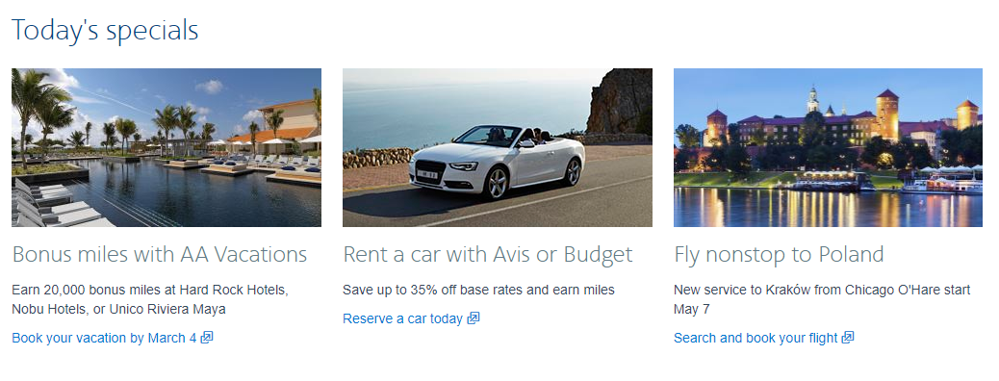

|  |  |  |  |
| --- | --- | --- | --- |
| **Data Attribute** | **Type of Entry** | **Data Type** | **Comments** |
| Picture | Picture | URL/Object | Required, NN |
| Headline | Entry | Text | Required, NN |
| Text | Entry | Text | Required, NN |
| Date | Entry | Date | Required, Default today, NN |

**Contact Us**

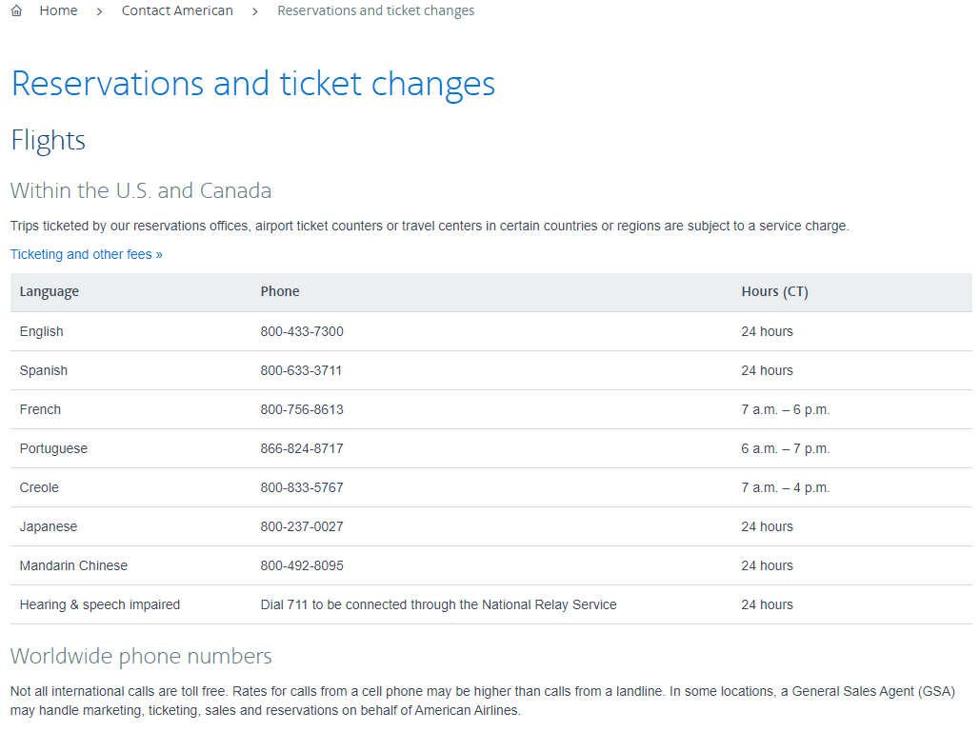

|  |  |  |  |
| --- | --- | --- | --- |
| **Data Attribute** | **Type of Entry** | **Data Type** | **Comments** |
| First Name | Entry | Alpha | Required, NN |
| Last Name | Entry | Alpha | Required, NN |
| Email | Entry | Alphanumeric | Required, FK |
| Phone | Entry | Numeric | Optional, FK |
| Subject | Entry | Alphanumeric | Required, NN |
| Message | Entry | Alphanumeric | Required, NN |